Mean, Median, Mode and Range-Questions
Key Stage 3: 2003 Paper 1 Level 5-7
1.
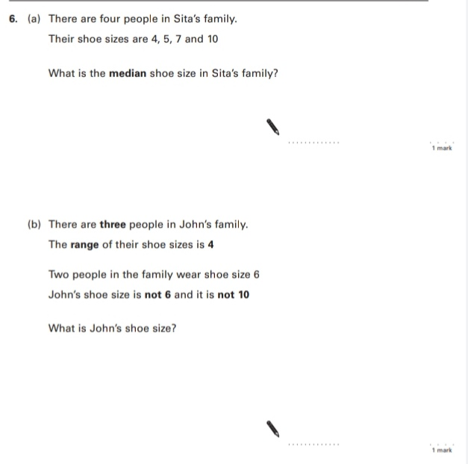
Key Stage 3: 2005 Paper 1 Level 5-7
2.
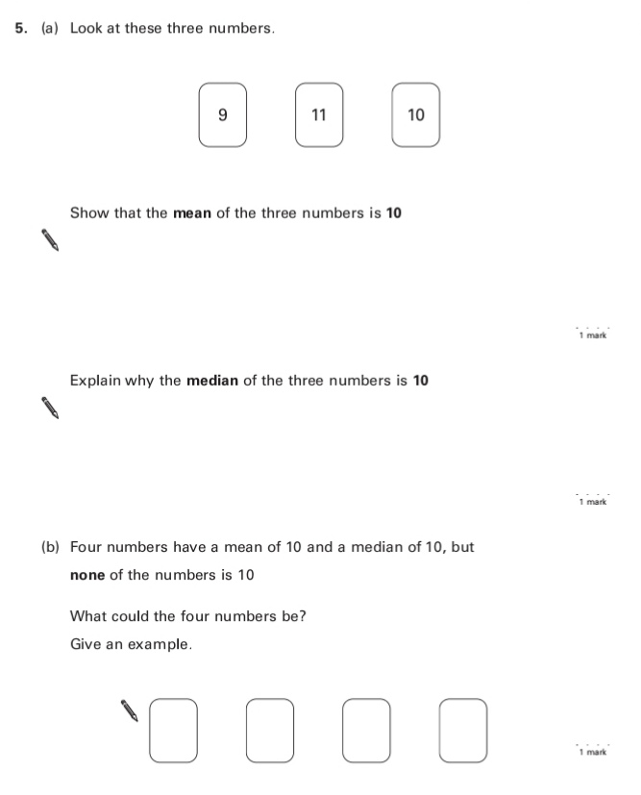
Key Stage 3: 2005 Paper 1 Level 6-8
3.
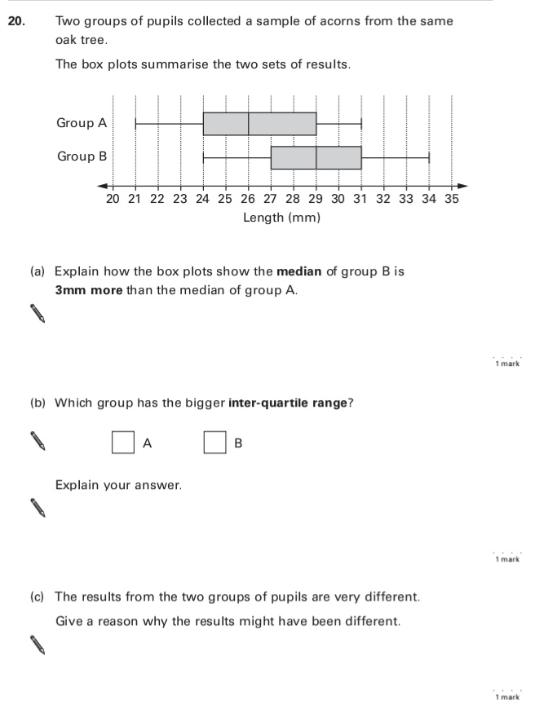
4.
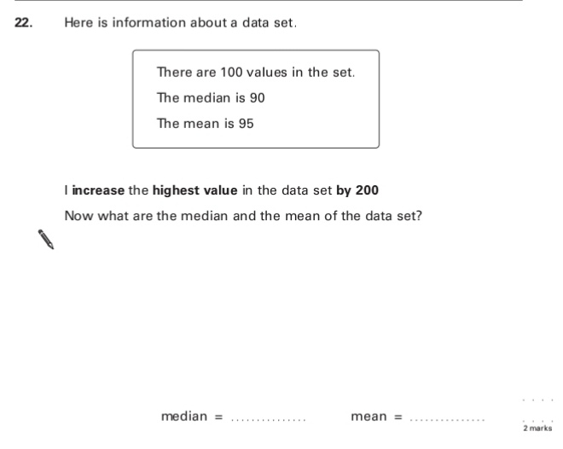
Key Stage 3: 2006 Paper 1 Level 5-7
5.
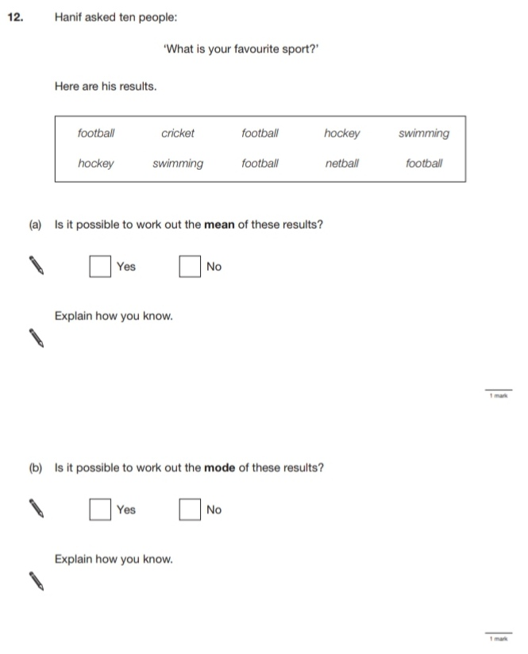
6.
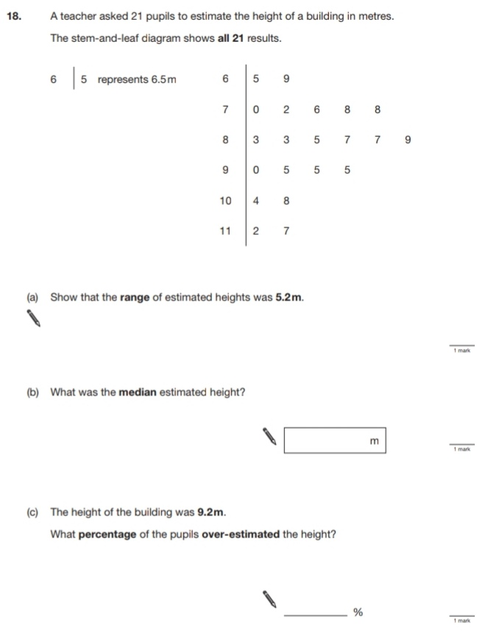
Key Stage 3: 2006 Paper 1 Level 6-8
7.
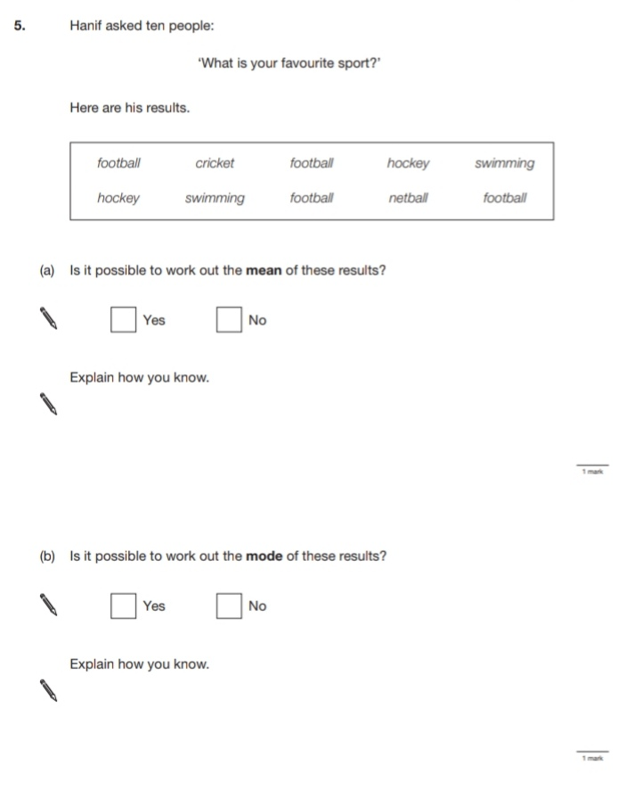
8.
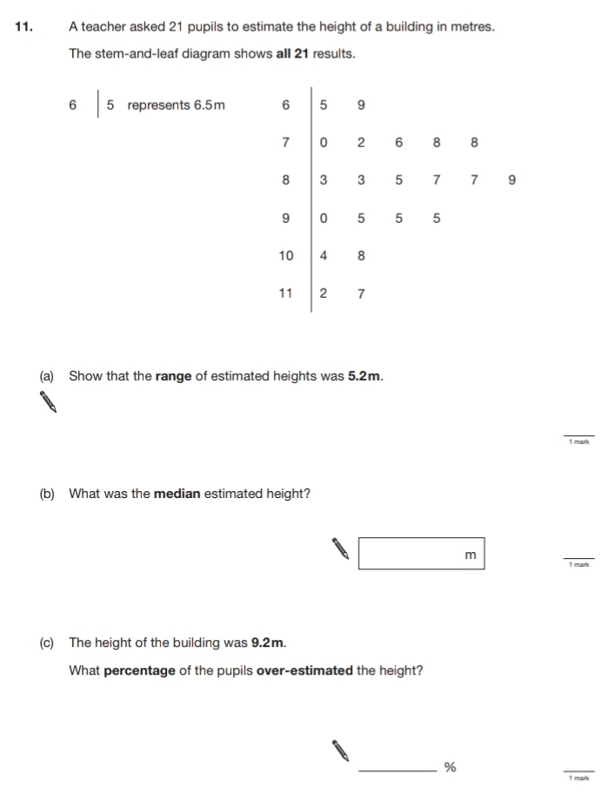
9.
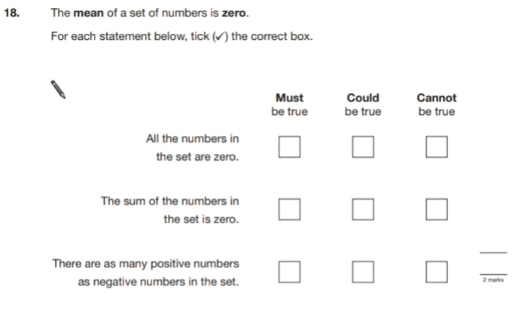
Key Stage 3: 2007 Paper 1 Level 5-7
10.
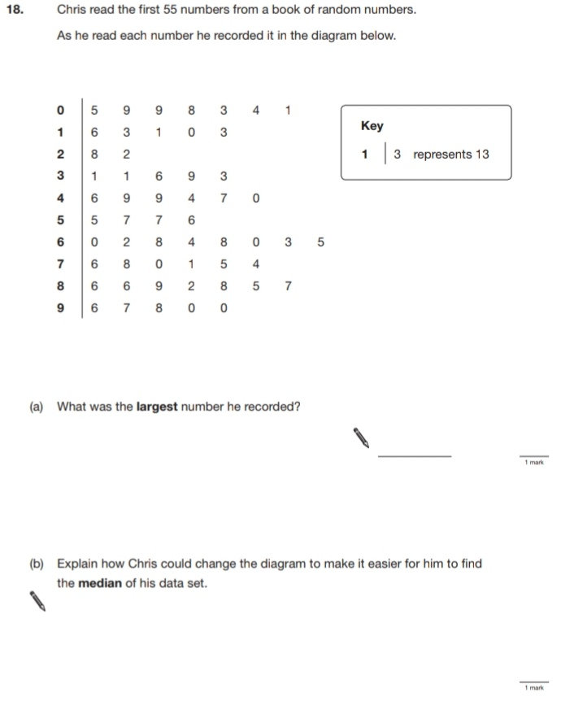
Key Stage 3: 2007 Paper 1 Level 6-8
11.
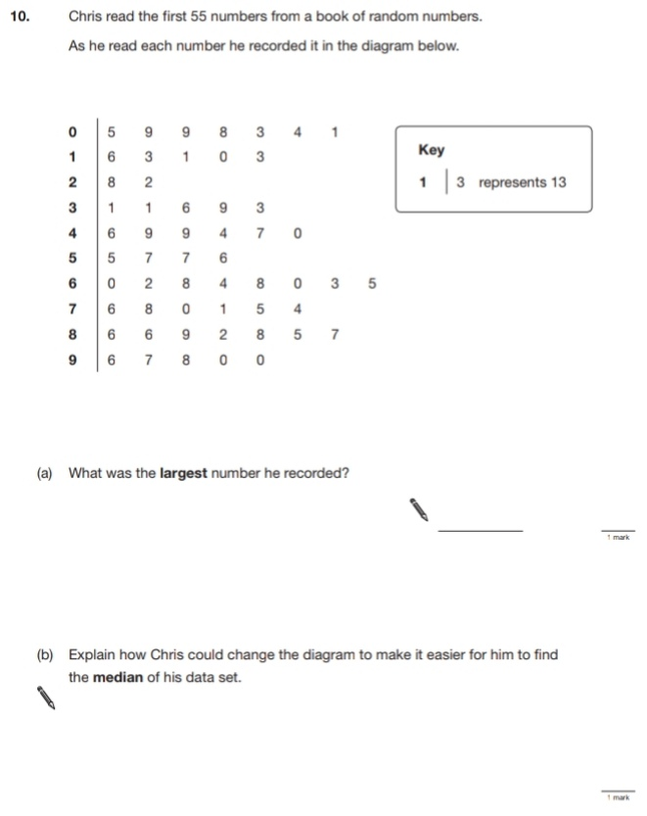
12.
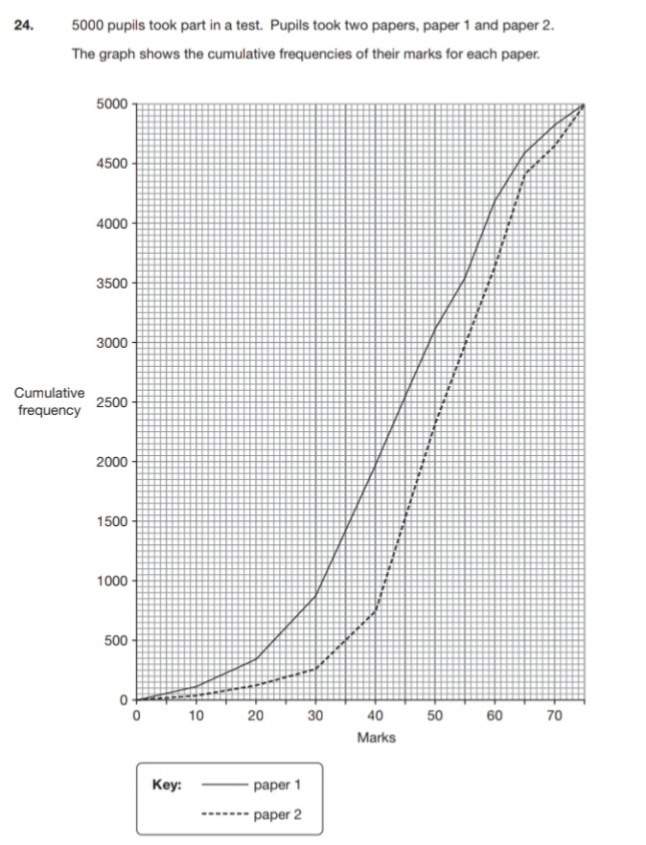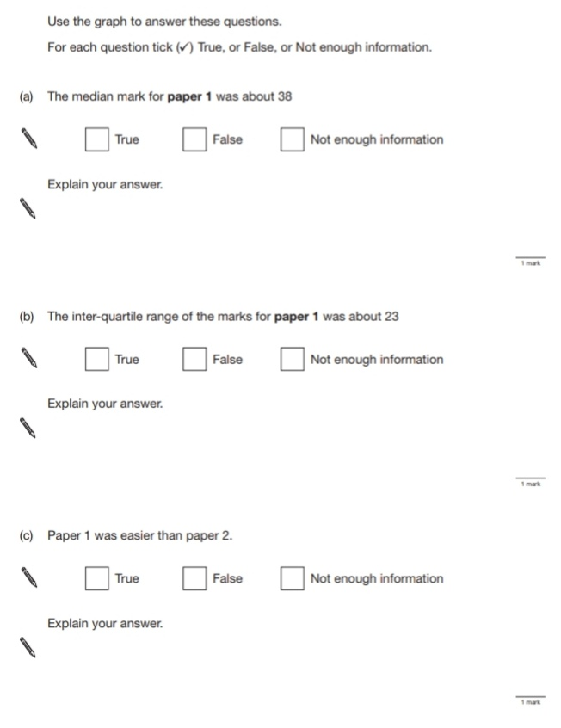
Key Stage 3: 2007 Paper 2 Level 6-8
13.
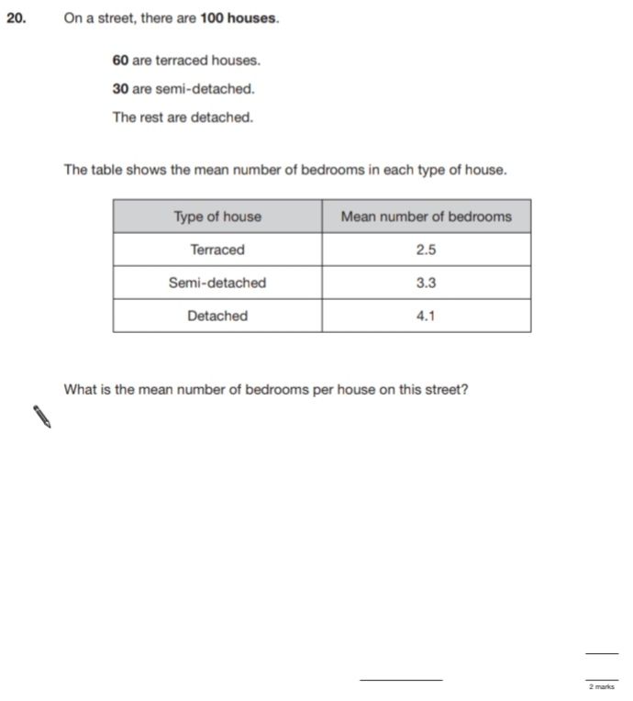
Key Stage 3: 2008 Paper 1 Level 5-7
14.
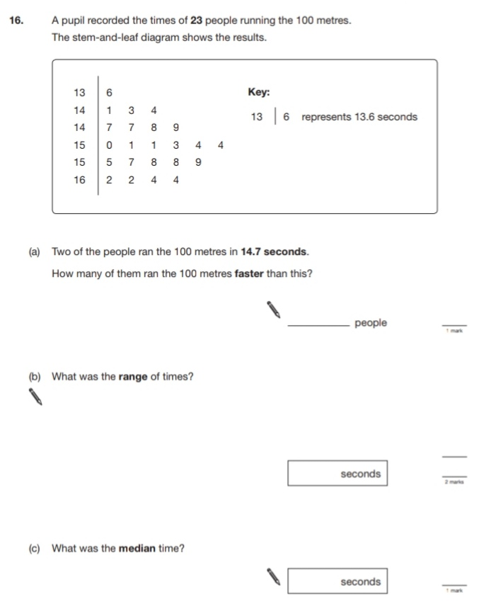
Key Stage 3: 2008 Paper 2 Level 5-7
15.
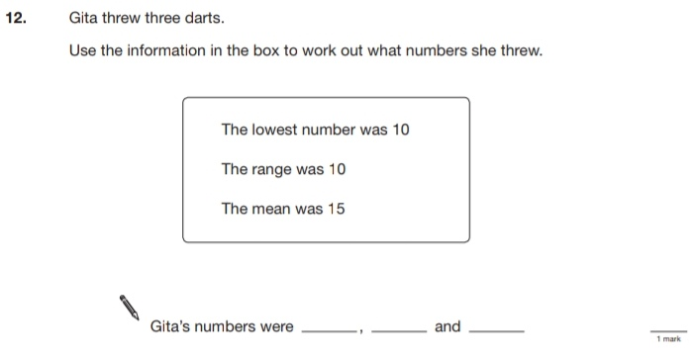
Key Stage 3: 2008 Paper 1 Level 6-8
16.
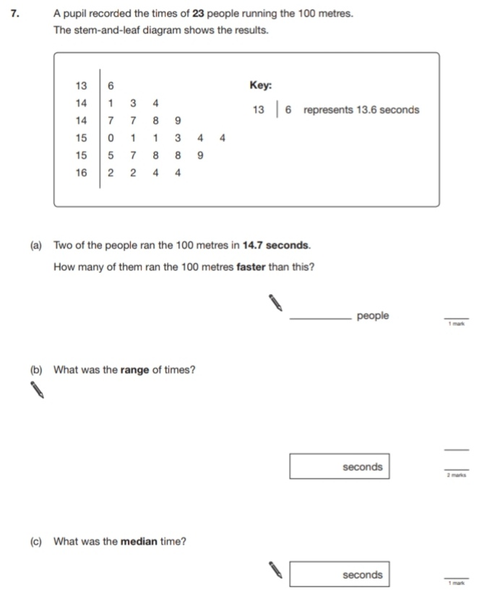
Key Stage 3: 2008 Paper 2 Level 6-8
17.
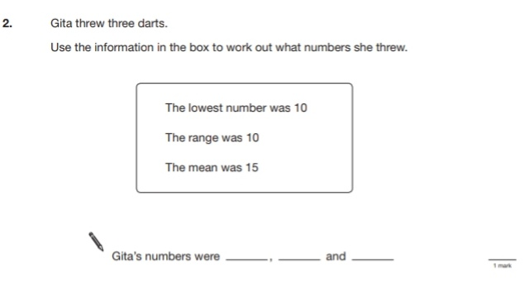
Key Stage 3: 2009 Paper 1 Level 5-7
18.
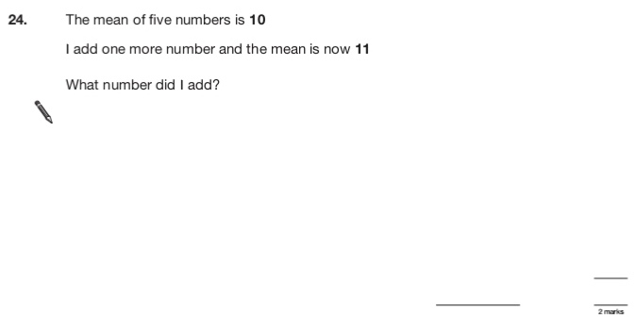
Key Stage 3: 2009 Paper 2 Level 5-7
19.
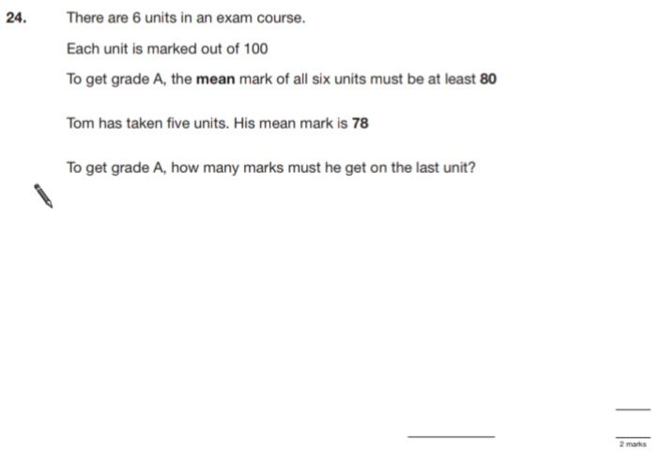 Key Stage 3: 2009 Paper 1 Level 6-8
20.
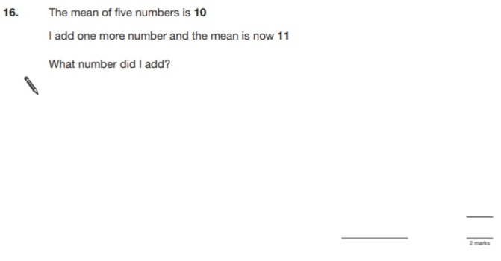
Key Stage 3: 2009 Paper 2 Level 6-8
21.
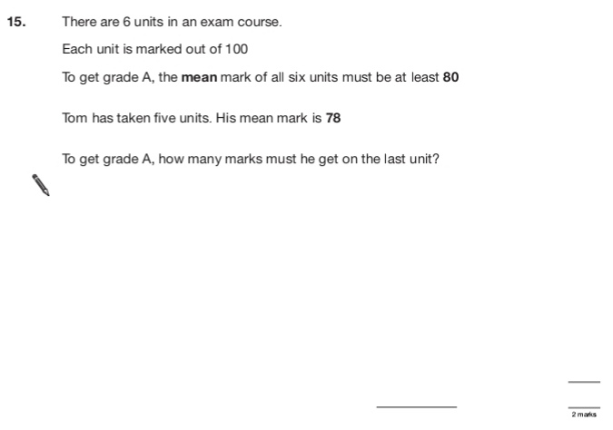
22.
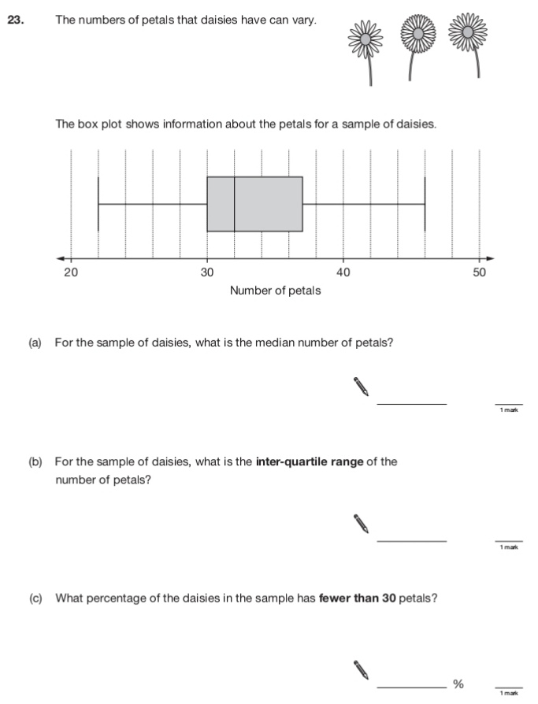
Key Stage 3: 2010 Paper 2 Level 5-7
23.
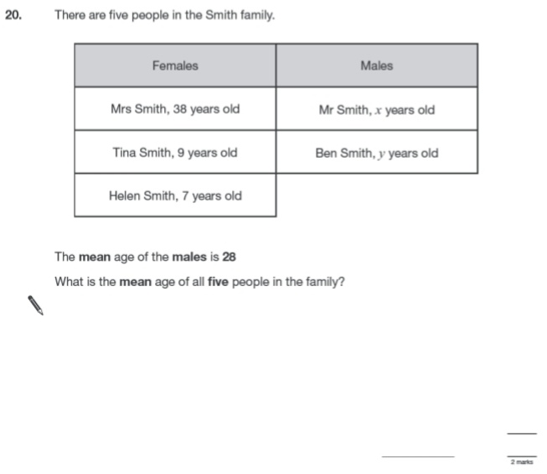
Key Stage 3: 2010 Paper 2 Level 6-8
24.
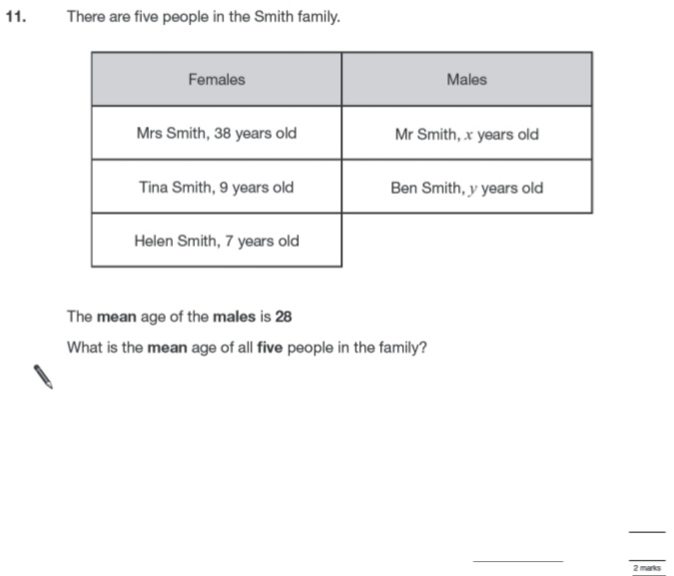
Key Stage 3: 2011 Paper 1 Level 5-7
25.
